This is the title of the presentation

First X. Author¹, Second Y. Author² and Third Z. Author¹

¹Department of Materials Engineering, KU Leuven
Kasteelpark Arenberg 44 bus 2450, 3001 Leuven, Belgium
Email: first.author@kuleuven.be, web page: www.composites-kuleuven.be

²Department of Mechanical Engineering, EPFL
MXH 145, 1015, Lausanne, Switzerland
Email: second.author@epfl.ch, web page: https://www.epfl.ch/labs/lpac/

Keywords: Polymer composites, Digital Image Correlation, Mechanical properties, Finite elements
Session topics: Constituent properties, Fibre-hybrid composites, Thin ply composites, Fatigue, Micromechanics, Delamination, Discontinuous fibre composites, Computed tomography, Multiscale modelling, Fracture toughness, Notch sensitivity, Novel experimental techniques, Bio-inspired design, (Pseudo-)ductile composites, Impact resistance, Structural applications

Abstract

The Conference publication will consist of a printed book containing abstracts of the accepted contributions. Authors should print their abstract to PDF, and name it “SurnameOfFirstAuthor.pdf”. This document should be emailed to hyfisynschoolandconference@gmail.com before the end of the submission deadline (at 23:59:59 Central European Time of the date mentioned on the conference website). Please mention in this email whether you would prefer an oral or a poster presentation.

The abstract must be written in English and have a maximum length of 2 pages in A4 ISO format (29.7 cm x 21 cm). Title of the presentation should be written centred, in 11pt boldface Times New Roman, all capital letters. Author’s name should include the unabbreviated first name, middle initial (if desired) and surname, and be written centred, in 11pt Times New Roman. Affiliation(s) should be written over three lines:
- Line 1: institution’s or company’s name
- Line 2: full address
- Line 3: email and (optionally) web page information
A maximum of five keywords (beginning with Keywords: boldfaced) should be added, separated by a comma, and written centred, in 11 pt Times New Roman. The first letter of each keyword should capitalised. A maximum of five topics (beginning with Session topics: boldfaced) must be selected from the list. The first letter of each topic should capitalised. Delete the ones that are not relevant for your abstract.

Leave one 11pt space after title, author(s), affiliation(s), keywords and session topics.

The abstract should be entitled with the word ABSTRACT centred, in 11 pt boldface Times New Roman. Leave one 11pt space after this title. The text should be written single-spaced, justified, using 11pt Times New Roman in one column. Margins are 3 cm on the top and 2.5 cm on the bottom, and 2.5 cm on the left and right (printing box of 24.2 cm x 16 cm). Leave one 11pt space between paragraphs. There is no indentation at the beginning of a paragraph.

Equations should be centred and numbered in an increasing order at the end of the line. Use 11pt for the symbols, letters and numbers in the equations. Leave one 11pt space above and below an equation to separate it from the surrounding text. There is no space between two equations. An example for an equation is given hereafter

$Kx=λMx$ (1)
Figures and Tables should be centred, numbered consecutively and captioned. Figure captions should appear below the figure, whereas table captions should appear above the table. Leave no space between the figure or table and the corresponding caption, but leave one 11 pt space above and below the figure/table/caption combination. The caption should be written centred, in 11pt Times New Roman, with upper and lower case letters. Examples of a figure (Figure 1) and a table (Table 1) are given below.

A paragraph at the end of the abstract (before the references) may be added for acknowledgments. No title is given to this paragraph.

The header of the second page should contain the author’s name (first name, middle initial if desired and surname), and be written centred, in 9pt Times New Roman.

The list of references (if any) should be placed at the end of the abstract and entitled with the word REFERENCES centred, in 11 pt boldface Times New Roman. References themselves should be in 10 pt Times New Roman. References should be quoted in the text by numbers ([1], [2,3] or [1-3]) and grouped together in the list of references in numerical order. For the style, please consult the references shown hereafter in a list of references including a journal paper [1], a book [2] and a conference proceeding [3]. An EndNote template for correct style formatting will be provided on the conference website.

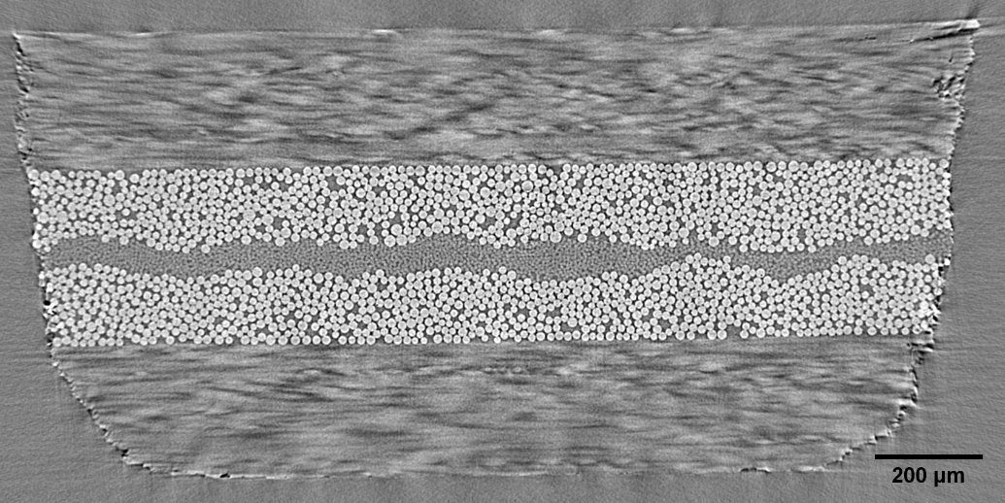
Figure 1: This is an example of a figure.

Table 1: This is an example of a table.
Fibre type | Weibull modulus | Weibull scale parameter
T300 | 3.9 + 0.4 | 3720 + 170
T700 | 4.9 + 0.7 | 4250 + 140
Τ800 | 4.3 + 0.5 | 4910 + 210

For more information about the instructions for the layout of the abstract, please contact the Secretariat of the Conference via email to hyfisynschoolandconference@gmail.com.

REFERENCES

[1] Y. Swolfs, L. Gorbatikh, I. Verpoest, Recent advances in fibre-hybrid composites: materials selection, opportunities and applications, International Materials Reviews, 64, 2019, p. 181-215.
[2] S.V. Lomov, Non-crimp fabric composites, 1st ed, Woodhead Publishing, Cambridge, 2011.
[3] Y. Swolfs, G. Czél, M. Jalalvand, M.R. Wisnom, I. Verpoest, L. Gorbatikh, Model validation of the hybrid effect in carbon/glass hybrid composites, In: Proceedings of the 7th International Conference on Composites Testing and Model Identification (Eds.: González C, López C, Llorca J), IMDEA, 8-10 April 2015.

